How to run CAVE VR Programs

# Opening the programs

## Option 1: Open from desktop shortcut

To open the programs from the desktop, show the desktop for the main screen (currently set to the right side of the long screen on the North wall, or the screen on the left of the VR computer table.)

Navigate to and open the shortcut for “CRIM_TARV” for the street crossing scene by CRIM, or to the shortcut for “Subway Platform Simulation” to open the subway platform.

The scene should automatically open and appear on the 4 screens after a brief loading screen.

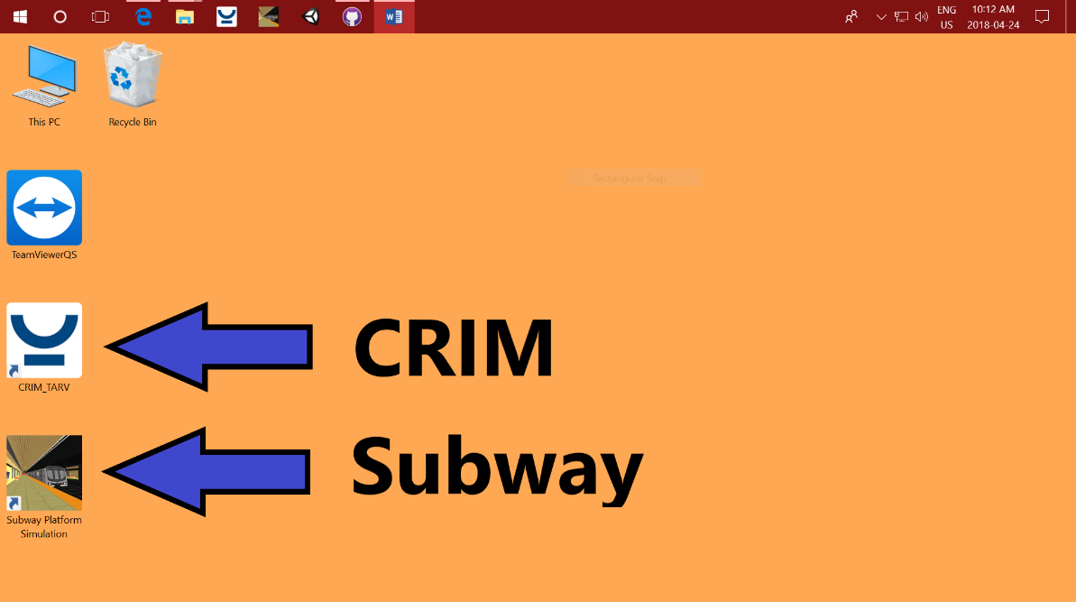

## Option 2: Open from taskbar

To open the programs from the taskbar, navigate to and open the “CRIM_TARV” or “Subway Platform Simulation” icon on the taskbar located at the top of the screens.

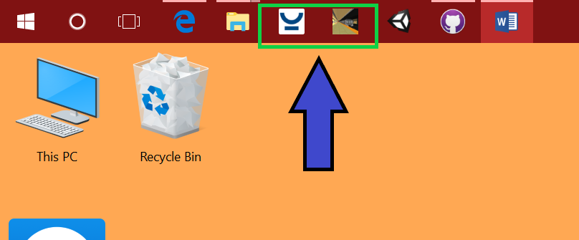

## Option 3: Open directly from .exe in program files

To open the programs directly from their .exe files, open windows explorer and navigate to the C Drive, then to Program Files, and open the “CRIM” folder or the “Subway Platform Simulation” folder.

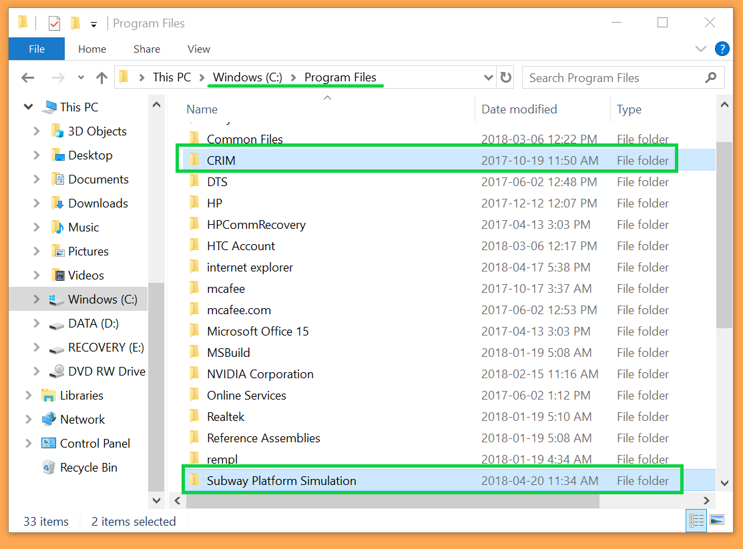

After opening the “CRIM” or “Subway Platform Simulation” folder, navigate to “CRIM_TARV_v73.exe” or “Subway Platform Simulation.exe” respectively, and run the programs.

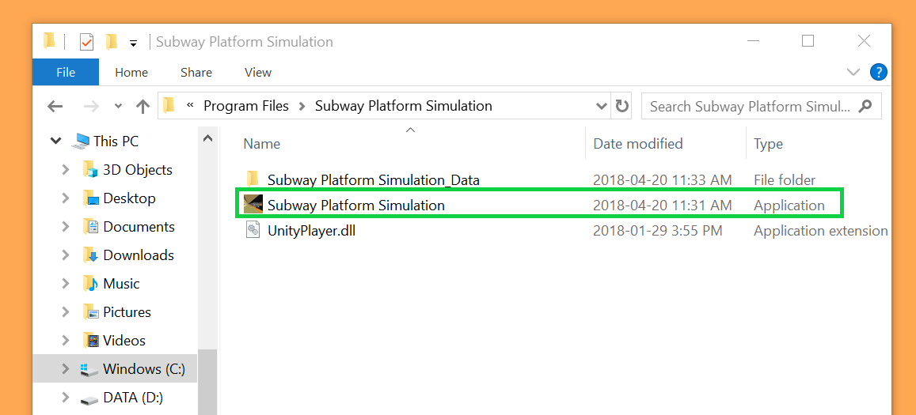

# Running the scene

## CRIM Street Scene

The CRIM simulation is controlled using the Samsung tablet and the CRIM app on it. The password for the Samsung tablet is 1234. The app has controls to change the weather, type of cars, speed, position on road, and activate sound distractions.

## Subway Platform Scene

The subway platform simulation will run automatically and loop every 10 minutes. The user is standing on the north side of the northbound platform of St. Clair subway station for this simulation. The scene has 3 subway arrival events, During the first event, the southbound and northbound train arrivals overlap, the second time, only the southbound train arrives, and lastly, the northbound train will arrive again.

# Troubleshooting

## Image projection issues

First, make sure the screens are positioned correctly and lined up with the markers on the ground. The projectors are projecting these images from extremely close distances, so any discrepancy in the projection surface with distort the image significantly.

If the projections are still off, try using the projector remote to refine display settings such as zoom, edge mask, image shift, and virtual keystone. If you need to isolate which projector settings you are changing, try using a tube to isolate the infrared light from the remote, and point the transmitter of the remote towards the receiver on the projector.

## CRIM Scene

Refer to the instructional documents provided by CRIM.

## Subway Platform Scene

If there are issues with the images on the screens not lining up with each other, the scene cameras may need adjustment within Unity. The project file can be found under “C:\Users\CNIB\Documents\GitHub\VR-Subway-Platform-Scene”. Open the file in Unity, open game view tabs for all 4 displays, and manually adjust the positions of Main Camera, Camera 2, Camera 3, and Camera 4. You may also need to adjust the Perspective shift R and Perspective shift L scripts, which can be done quickly from the inspector after selecting the Game Manager gameobject, which has the aforementioned scripts attached as components. If this is adjusted, the scene will need to be exported and built again, and the files in “C:\Program Files\Subway Platform Simulation” replaced with the new build.

A backup of the project folder can be found at <https://github.com/xiajenny/VR-Subway-Platform-Scene> and forked or cloned to restore the files. Contact Jenny at [jieni.xia@gmail.com](mailto:jieni.xia@gmail.com) if further issues are experienced.